What it is About?  When living in Supported Housing you have a responsibility to keep to the terms of your Occupancy Agreement and the House Rules. These protect your rights to live in peace but also place responsibilities on you conduct yourself in a way that does not cause disturbance to your neighbours who hold the same rights as you.  This leaflet explains what happens if you are unable to take responsibility for actions that are not acceptable.  Types of Breaches  These may include:  - Not following the tenancy agreement  - Not following the house rules  - Criminal activity on the premises  - Not accessing the support  - Anti-social behaviour  - Activity that puts staff and people who live in the same building at risk  Abandonment is where you may decide not to stay with us but don’t let us know – we want to support you to feel you can stay  Non-payment of rent will be addressed through your accommodation provider’s process.  Discussion First  If you have acted in a way that breaches your tenancy agreement or the House Rules or we think you are not staying in your property your Support Worker will discuss this with you and explore how you can prevent this from reoccurring including how we can support you. | Action That Can Be Taken  Where behaviour is deemed serious action can be taken to remind you that this is not acceptable, such as:  - Sanctions  - 1st, 2nd & 3rd Warnings  - Acceptable Behaviour Agreement  - Potential Loss of Accommodation Notice  - Conditional Notice  - Notice to End the Tenancy (eviction)  A Conditional Notice outlines specific conditions that must be met to prevent you from losing your accommodation.  An Acceptable Behaviour Agreement can be drawn up to help maintain accommodation and reduce anti-social behaviour.  All of these can be reviewed up to 28 days after being issued to see if they will be removed, amended or continue; this depends on you showing a positive change in behaviour.  Appeals  Write to the Accommodation Manager within 5 days to appeal any action taken you disagree with. An advocate can be provided.  Within 3 days from receiving the appeal a meeting will hear the appeal. An advocate can be present. You will receive the decision of the appeal meeting within 2 days. | Your Input    If you have been asked to meet to discuss an alleged breach or signs of abandonment use this blank section to write down your thoughts and the facts on what happened. This will help you discuss things with your Support Worker:  Remember: We are here to Support You  You are at risk of becoming homeless if you are unable to resolve issues.
  What happened?
  Why things have not gone right?
  What things you can do to change for the future?
What Agencies are Involved with the Scheme?  Housing Solutions @ THE HUB works Across North Yorkshire  -   -   -   -   -   -   -   -   -   -   -   -   -  | Contact details  Insert Scheme Details:  This publication is available in alternative formats, such as large print, on request.  This Leaflet has been explained to me by a Support Worker at induction.  Signed:..............................Date:............  Reviewed: February 2018  Appendix 9b STEP Leaflet | STEP  Sustaining Tenancies & Eviction Prevention      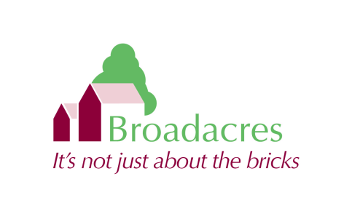  For Young People in Pathway 2 Supported Accommodation

